**Uniforms pt.2** –

* [Alternative Unisex Weathered Tee](https://www.sanmar.com/p/8452_WashedBlack#?doScrollToGrid=true), AA6094, $11.90 (image 1)
  + Good value, contemporary cut, offer white, black and blue color options.
* [Alternative Women’s Backstage Vintage Tee](https://www.sanmar.com/p/7778_White#?doScrollToGrid=true), AA5064, $11.90 (image 2)
  + Good value, contemporary cut, would be specifically for the individuals who prefer this type of cut, offer white, black, and blue color options.
* [Bella+Canvas Unisex Triblend Tee](https://www.sanmar.com/p/9267_SldBlackTB), BC3414, $10.28 (image 3)
  + 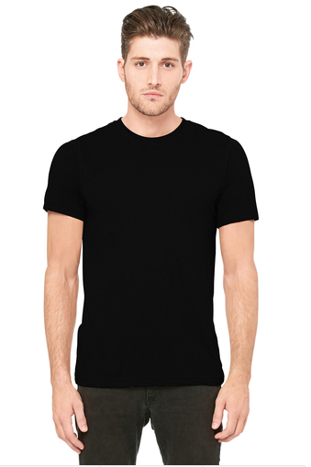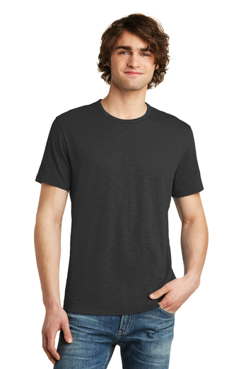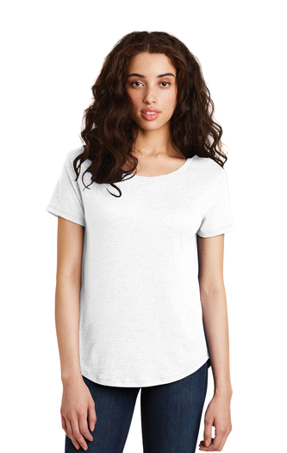Good value, contemporary cut, bit of an intermediary between the two styles above, and comes with excessive amount of color options.